**Name:** Abin Sunil

**Roll No**:1

**Batch:** R-MCA

**Date:** 03-06-2022

**ADVANCED DBMS LAB**

**Experiment No: 8**

**Aim**

Create database and Practice CRUD operations

**Procedure**

**Step1:** Create data base and inert tables.

use my_project_db

show dbs

db.createCollection("mydb")

db.createCollection("movie")

db.movie.insert({"name":"Avengers: Endgame"})

db.movie.insert(

[

  {"name": "Avengers: Infinity War" },

  { "name": "Avengers: Endgame" }

]

)

db.developers.insertMany(

[

  { _id: 20, devname: "John Wick", tools: "Visual Studio", born: 1948 },

  { _id: 21, devname: "Ganesh Roy", tools: "Net Beans", born: 1945 },

  { _id: 22, devname: "Deeksha Raul", tools: "Unity 3D", born: 1954 }

]

)

**Output**

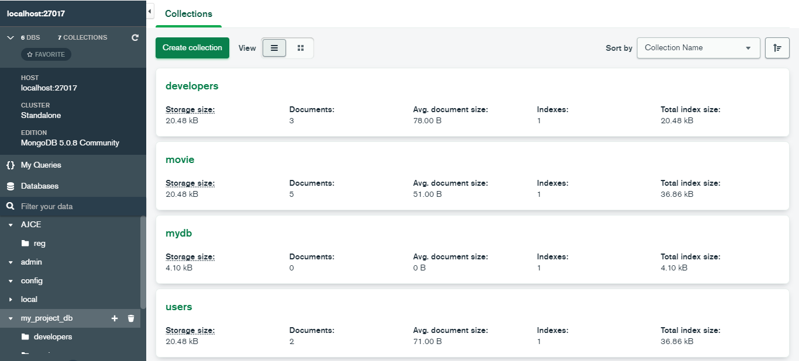

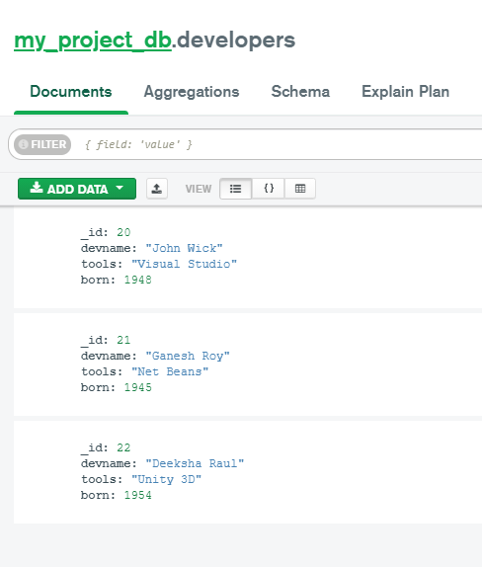

**CRUD operation**

**Step 2:** Create or insert operations add new [documents](https://www.mongodb.com/docs/manual/core/document/#std-label-bson-document-format) to a [collection](https://www.mongodb.com/docs/manual/core/databases-and-collections/#std-label-collections).

db.details.**insertOne**({name:"Rohit",age:"27",status:"pending"})

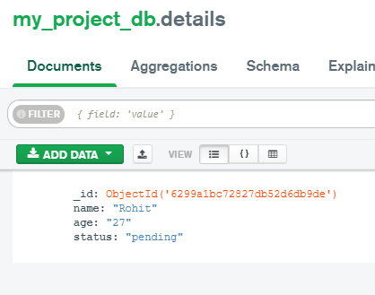

db.details.**insertMany**([{name:"Rohit",age:"27",status:"pending"},{name:"Aswathy",age:22,status:"pending"},{name:"Aswin",age:26,status:"pending"}])

**Output:**

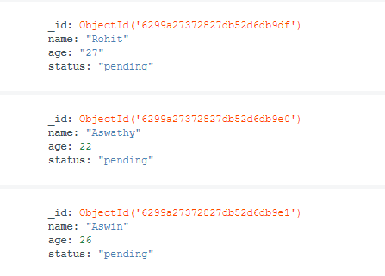

Step 3: Read operations retrieve [documents](https://www.mongodb.com/docs/manual/core/document/#std-label-bson-document-format) from a [collection](https://www.mongodb.com/docs/manual/core/databases-and-collections/#std-label-collections)

db.details.find({age:{$gt:25}},{name:1,address:1}).limit(5)

**Output:**



**Step 4:** Update operations, which modify existing [documents](https://www.mongodb.com/docs/manual/core/document/#std-label-bson-document-format) in a [collection](https://www.mongodb.com/docs/manual/core/databases-and-collections/#std-label-collections).

  db.details.**updateMany**({age:{$gt:25}},{$set:{status:"reject"}})

**Output:**



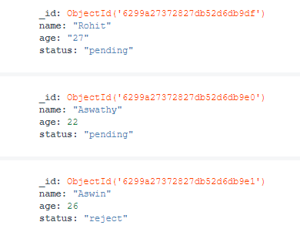

db.details.**updateOne**({name:"Aswathy"},{$set:{status:"selected"}})

**Output:**



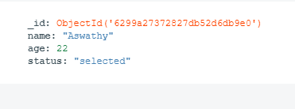

**Step 5:** Delete operations, which remove documents from a collection.

db.details.**deleteMany**({status:"reject"})

**Output:**



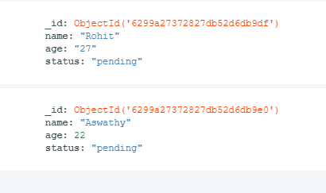

db.details.deleteOne({name:"Rohit"})

**Output;**



